Example Campaign Template
Use this template as an example to customize your GO Dough page.
You can cut and past the text in this document and enter it into the field on your page on Fundrazr.com. Or create your own!

Building Healthy Bodies and Minds

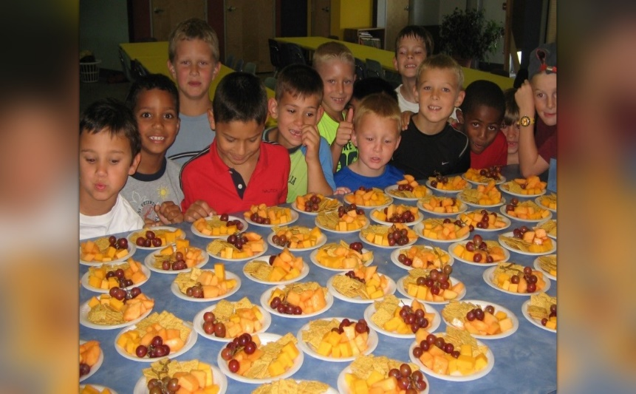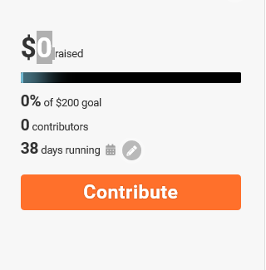
Change the title to fit your campaign
Replace the default picture with a picture of your school or students

Once you register your campaign page, you can customize it to fit your school and your needs.
Things that you should edit: Pictures, Title, Story, URL.
Cut and paste the text in this example document or create your own.

Go to Edit button at the top of your GO Dough page

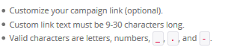
5 Essentials for an Effective Story
An effective story informs and inspires. Here’s what you should include:
1. Introduce yourself
2. Introduce your cause
Describe your cause, its importance, the people involved, and what you’re trying to achieve
3. Say what the money is for
Explain how the money you raise will be used. Give details. They build trust
4. Ask for help
Ask people to contribute money and share your campaign. If you don’t ask, people won’t ask.
5. Be personal, detailed and optimistic
People respond to authenticity, information, and hope.

You can edit your story ANY time.

fundrazr.com/yourschoolname Customize
Healthy Bodies and Minds

Copy and paste this story or write your own!

Hello, my name is ______ and I'm the PE teacher at _________School. Thank you for visiting our fundraising campaign page!

OUR WELLNESS PROGRAM
Students at ________ are eager and enthusiastic about physical education and health! Our school community values the whole child and we strive to make health and wellness a priority as a foundation for teaching and learning.
HOW YOUR DONATION SUPPORTS HEALTH AND WELLNESS FOR STUDENTS AND FAMILIES
Please consider donating to strengthen our school wellness program and sharing this page with your family and friends! Meeting our $1,000 goal will provide:
- $150 - Produce for fruit & vegetable tastings
- $200 - Professional development for PE & Health teacher
- $200 - PE Equipment
- $200 - Family fitness night supplies & promotion
- $250 - Support SHAPE Arkansas and school wellness nationwide

List items that you would like to fundraise for.
It’s important to be transparent!

